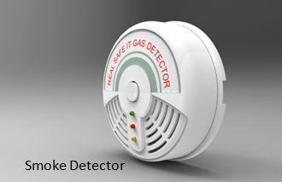

**Product design for Smoke Detector**

Product design of a smoke detector primarily involves a **disk-shaped plastic enclosure** engineered to securely house internal electronic components, facilitate air/smoke entry into a sensing chamber, and meet safety standards.

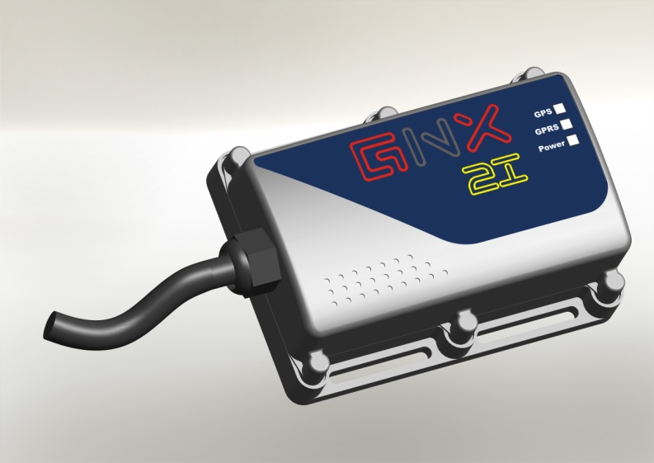

**Automotive product design for Vehicle tracking system**

1. Aesthetical improved Compact Design of VTS.
2. Engineering Design & Detailing of VTS.
3. Engineering design with IP 65 Protection.

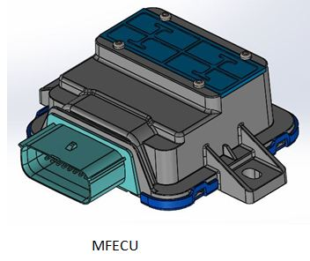

**Engineering design for MFECU**

1) Compact Engineering Design for MFECU. Plastic Enclosure Housing & Top cover – Plastic ABS material for MFECU

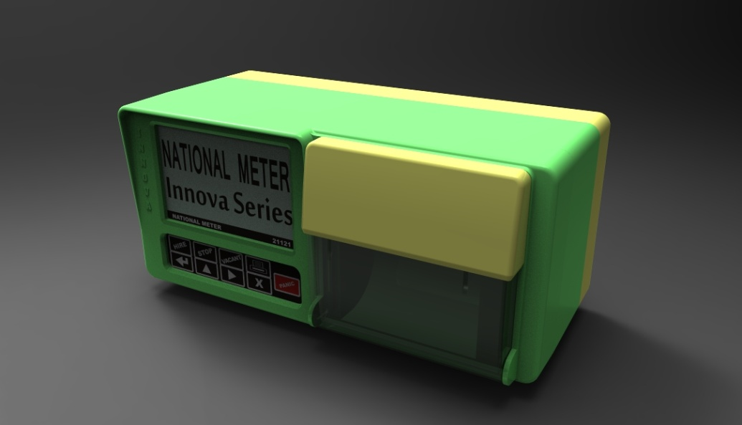

**Enclosure Design for Taximeter**

1. Aesthetically improved Compact Design of Plastic Enclosure Housing – Plastic ABS +PC with IP65 protection for Taximeter.
2. Engineering Design for Printer Mounting.
3. Engineering Design of Cover in PC for Paper Roll.
4. LED Illuminated indication on the back side of Meter for ‘FOR HIRE’.
5. Engineering Design for Meter Mounting on Taxi/Rickshaw.

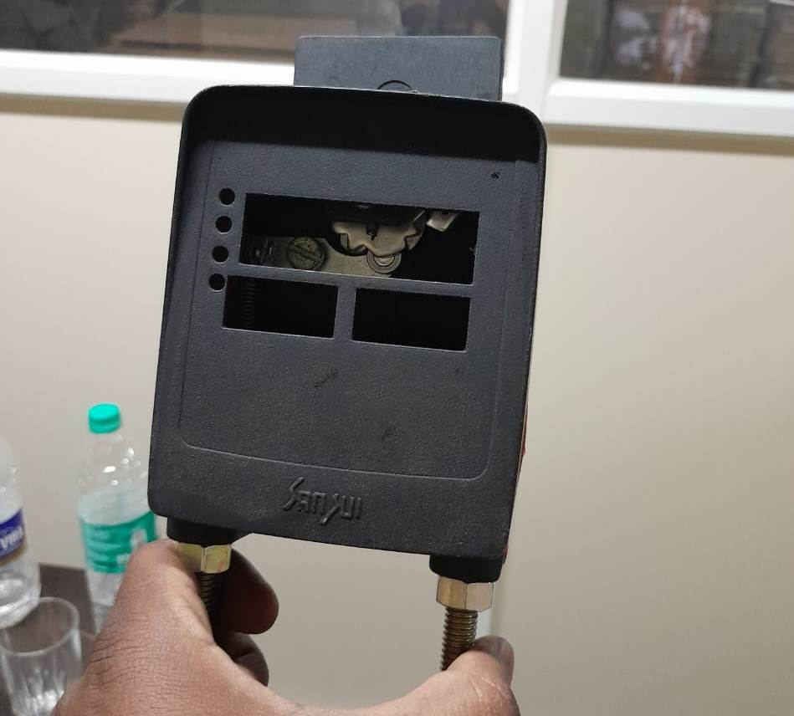

**Prototype development for Jumbo meter flag compact**

3D printed prototype development for breakthrough ideas

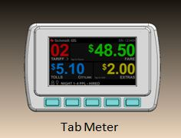

**Electromechanical Product Design for Tabmeter**

1. Aesthetically improved Compact Design of Plastic Enclosure. Housing – Plastic ABS +PC with IP65 protection for Tabmeter.
2. Engineering Design for display Mounting.
3. Engineering Design for Meter Mounting on Taxi/Rickshaw.

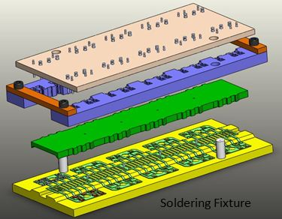

**CAD Modeling and Mechanical design for soldering fixture**

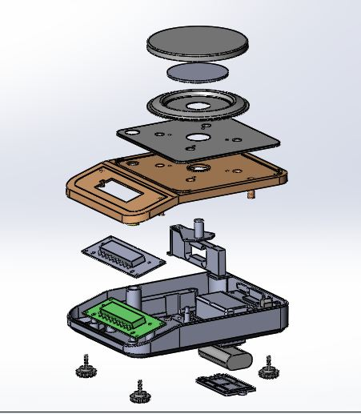

Plastic product design for JW weighing scale Precision 600g

1. Aesthetically improved Compact Design of Plastic Enclosure. Housing – Plastic ABS with IP54 protection for weighing scale.
2. Engineering Design for electronics and weighing scale Mounting.

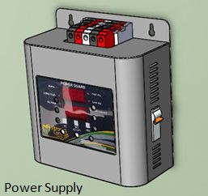

Sheet metal design for Power supply

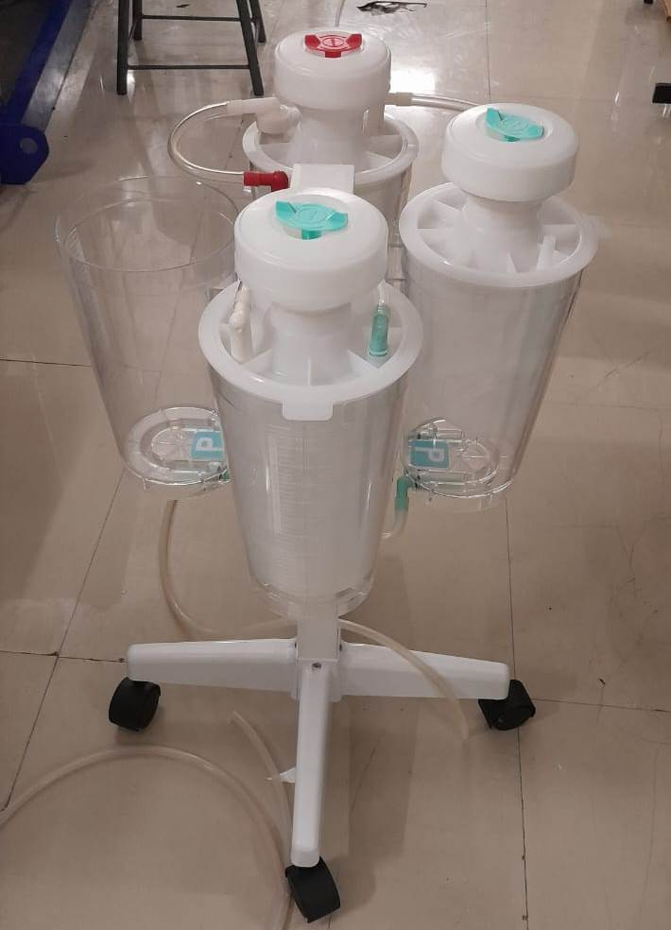

Reverse engineering for Suction unit (Medical product)

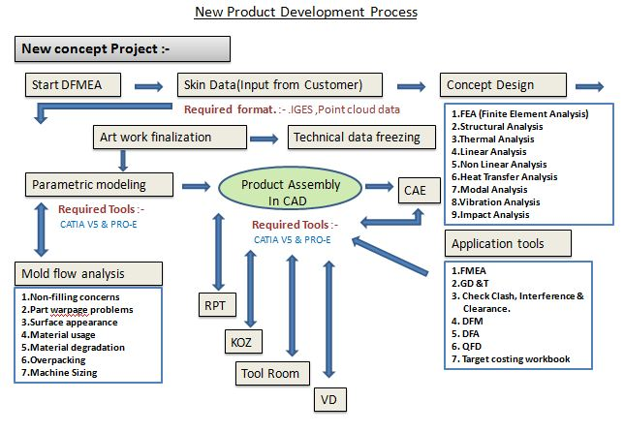

New Product Development process



Onsite Service

Get multi-disciplinary experts without the cost of full-time employees

Engage specialized skills for specific project durations

Affordable solutions, especially for small, medium and large businesses

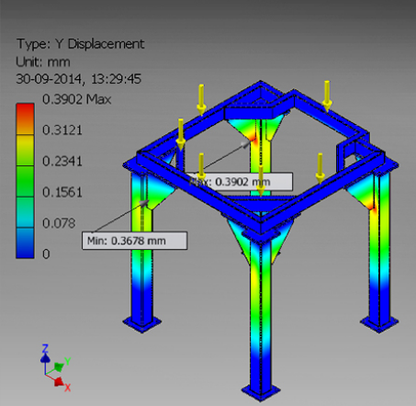

**Design Analysis**

To verify design, perform various type of analysis like,

* Structural analysis (Static/Dynamic)
* Thermal analysis
* Environmental test analysis
* Vibration analysis
* CFD etc